Private Letter Ruling
Ruling Number: | P-2016-006

Tax Type: | Individual Income Tax
Brief Description: | Income Tax Treatment of Roth IRA Distributions
Keywords:
Effective Date: | 08/16/2016
Approval Date: | 08/16/2016

Body:
August 16, 2016
XXXXXXXXXX
XXXXXXXXXX
Re: Kansas Income Tax
Dear XXXXX
Your correspondence of August 11, 2016, has been referred to me for response. Thank you for your inquiry.
By your e-mail you have requested our advice regarding Kansas income tax. Specifically, your e-mail states:
Does Kansas collect income tax on qualified Roth IRA distributions?
In response to your question, please be advised Kansas law requires the use of federal adjusted gross income as the starting point for computing the Kansas income tax. In the absence of a specific modification, items that are subject to federal tax will be subject to Kansas tax. Similarly, those items that are exempt from federal tax will be exempt from Kansas tax.
Kansas law does not include a specific modification that deals with Roth IRAs. As a result, the tax treated accorded a Roth IRA under federal law will flow though to Kansas. If the money you withdraw from your Roth IRA is exempt from federal income tax it will be exempt from Kansas income tax.
I trust this information is of assistance. If I can be of further service, please feel free to contact me.
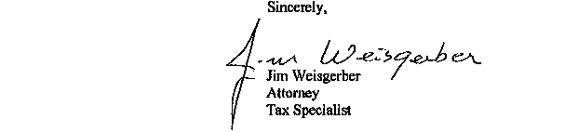
JW:jw
NOTE: This opinion letter is based solely on the facts provided in your request for advice. If material facts or information were not disclosed this letter is null and void. This letter will be revoked without further action by the Department if the statutes, administrative regulations, published revenue rulings, or court decisions that materially affect this opinion are changed.
Date Composed: 09/16/2016 Date Modified: 09/16/2016

